# **Lab - Configure VPC**

Traditional networking is hard — it involves equipment, cabling, complex configurations and specialist skills. Fortunately, Amazon VPC hides the complexity while making it easy to deploy secure private networks.

This lab shows you how to build your own Virtual Private Cloud and deploy resources.

The lab will demonstrate how to:

* **Create** a Virtual Private Cloud (VPC) that contains a private and public subnet, an Internet Gateway (IGW), and a Network Translation (NAT) Gateway.
* **Configure** Route Tables associated with a public subnet for internet-bound traffic to be directed to the IGW for direct internet access.
* **Configure** Route Tables associated with a private subnet for isolated resources to securely connect to the internet through a NAT Gateway.
* **Launch** a Bastion Host in a public subnet for resource-based secured access to the private subnet.
* **Evaluate** the operation of the private subnet's ability to communicate with the internet.

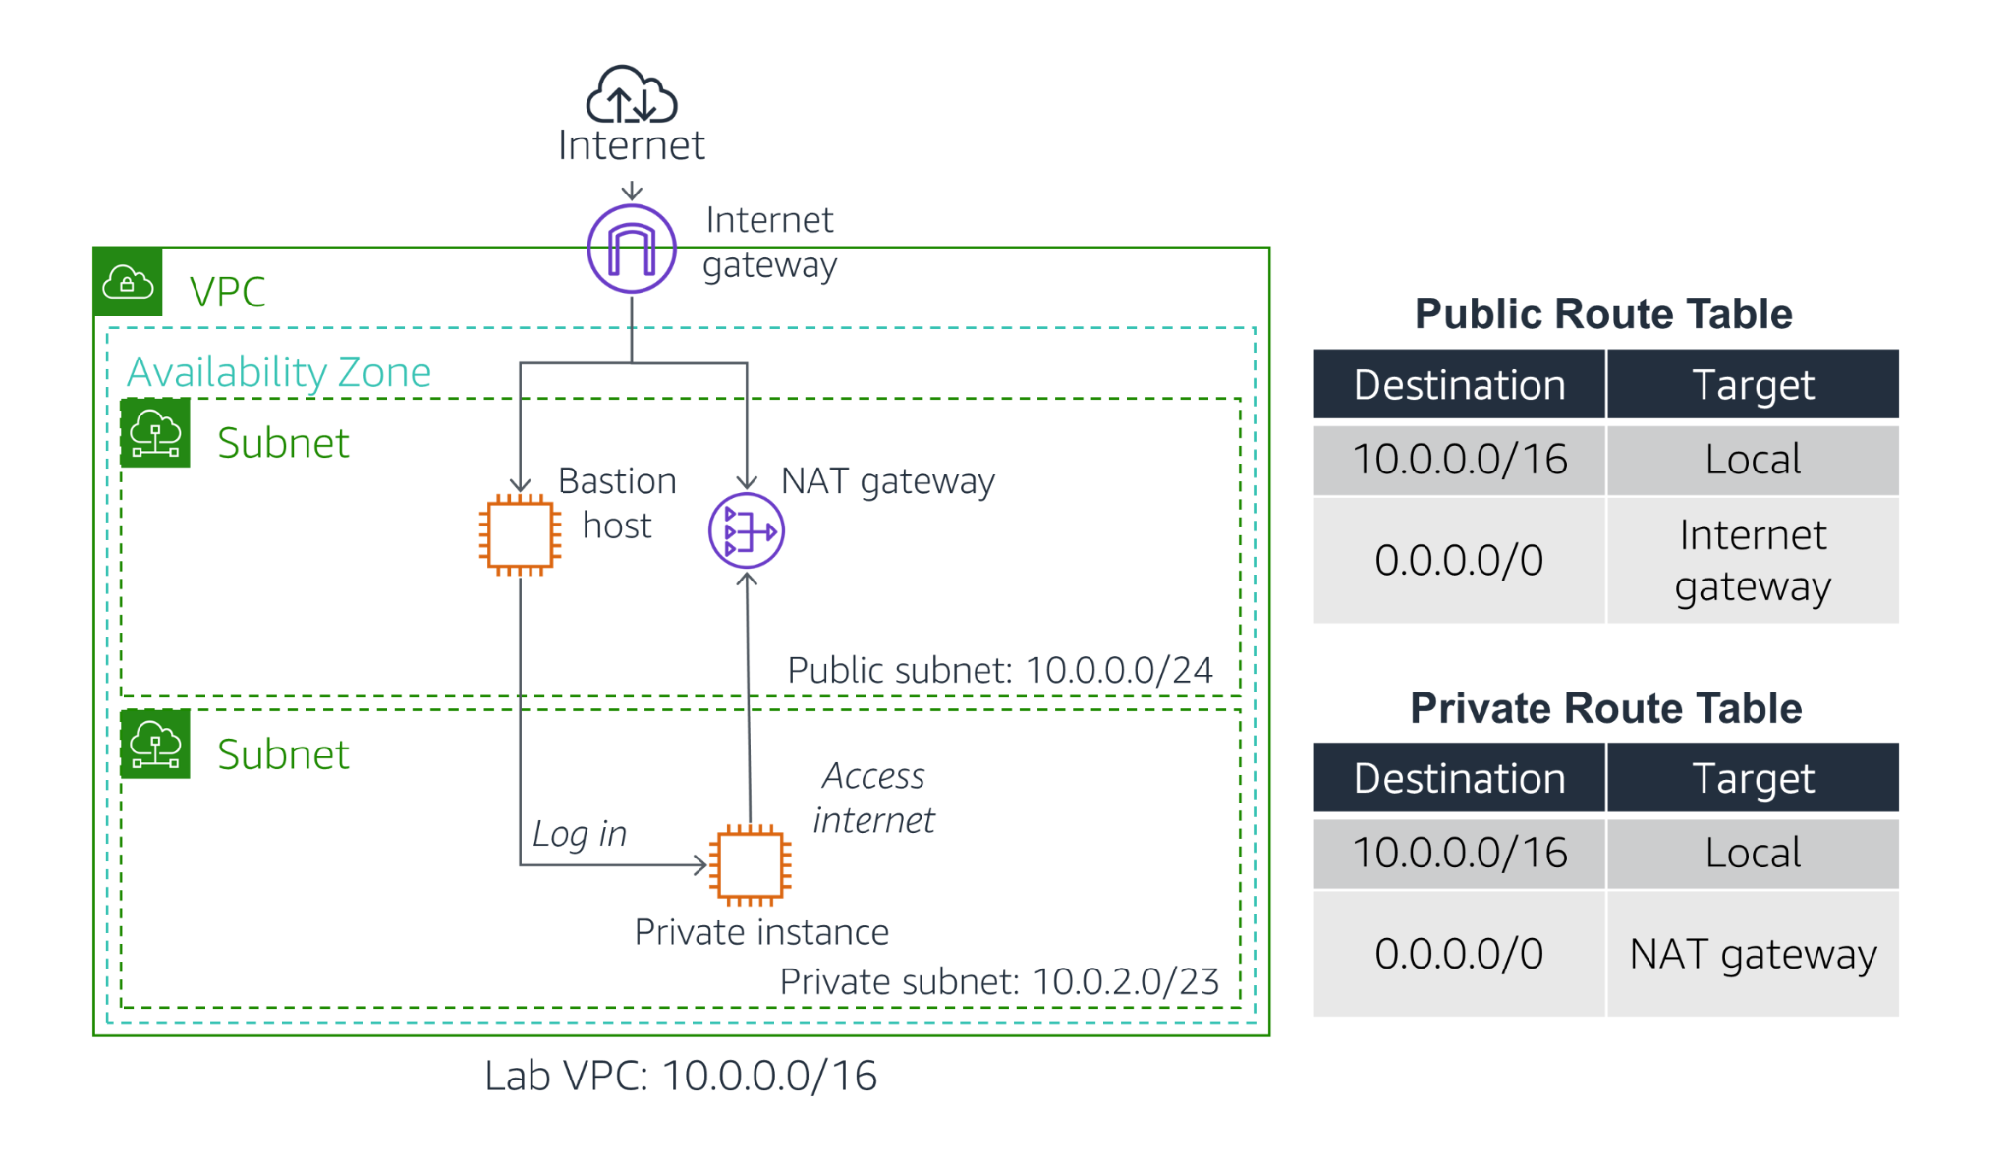

If you have time, an **optional Challenge section** will then have you create an Amazon EC2 instance in a private subnet and connect to it via the Bastion Server.

**Duration**

This lab will require approximately **45 minutes** to complete.

## **Accessing the AWS Management Console**

1. At the top of these instructions, click Start Lab to launch your lab.  
   A Start Lab panel opens displaying the lab status.
2. Wait until you see the message "**Lab status: ready**", then click the **X** to close the Start Lab panel.
3. At the top of these instructions, click AWS  
   This will open the AWS Management Console in a new browser tab. The system will automatically log you in.  
   **Tip**: If a new browser tab does not open, there will typically be a banner or icon at the top of your browser indicating that your browser is preventing the site from opening pop-up windows. Click on the banner or icon and choose "Allow pop ups."
4. Arrange the AWS Management Console tab so that it displays along side these instructions. Ideally, you will be able to see both browser tabs at the same time, to make it easier to follow the lab steps.  
    Please do not change the Region during this lab.

## **Task 1: Create a VPC**

You will begin by creating a new **Virtual Private Cloud (VPC)**.

A VPC is a virtual network dedicated to your AWS account. It is logically isolated from other virtual networks in the AWS cloud. You can launch AWS resources, such as Amazon EC2 instances, into the VPC. You can configure the VPC by modifying its IP address range, create subnets, and configure route tables, network gateways, and security settings.

1. In the **AWS Management Console**, on the **Services** menu, click **VPC**.  
   The VPC console offers a *VPC Wizard* that can automatically create several VPC architectures. However, in this lab you will be creating the VPC components manually.
2. In the left navigation pane, click **Your VPCs**.  
   A default VPC is provided so that you can launch resources as soon as you start using AWS. However, you will create your own *Lab VPC*.  
   The VPC will have a CIDR range of **10.0.0.0/16**, which includes all IP address that start with **10.0.x.x** — containing over 65,000 addresses. You will later divide the addresses into separate *subnets*. [CIDR Calculators](http://www.subnet-calculator.com/cidr.php) can help determine the correct set of IP addresses.
3. Click **Create VPC** and configure:
   * **Name tag:** Lab VPC
   * **IPv4 CIDR block:** 10.0.0.0/16
   * Click **Create VPC** then **Close**
4. Select **Lab VPC**, ensuring that it is the only VPC selected.
5. Click **Actions**  and select **Edit DNS hostnames**.  
   This option assigns a friendly DNS name to Amazon EC2 instances in the VPC, such as:  
   *ec2-52-42-133-255.us-west-2.compute.amazonaws.com*
6. Select **enable**, then click **Save changes**Any Amazon EC2 instances launched into the VPC will now automatically receive a DNS hostname. You can also add a more meaningful DNS Name (eg *app.company.com*) later by using Amazon Route 53.

## **Task 2: Create Subnets**

A subnet is a sub-range of IP addresses within the VPC. AWS resources can be launched into a specified subnet. Use a *public subnet* for resources that must be connected to the internet, and use a *private subnet* for resources that are to remain isolated from the internet.

In this task, you will create a public subnet and a private subnet:

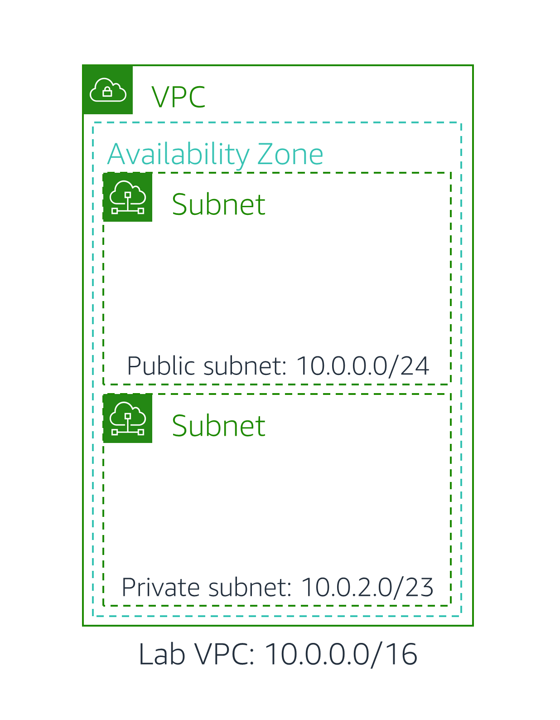

### **Create a Public Subnet**

The public subnet will be used for internet-facing resources.

1. In the left navigation pane, click **Subnets**.
2. Click **Create subnet** and configure:
   * **VPC ID:** *Lab VPC*
   * **Subnet name:** Public Subnet
   * **Availability Zone:** Select the *first* AZ in the list
   * **IPv4 CIDR block:** 10.0.0.0/24
   * Click **Create subnet**
3. The VPC has a CIDR of **10.0.0.0/16**, which includes all **10.0.x.x** IP addresses. The subnet you just created has a CIDR of **10.0.0.0/24**, which includes all **10.0.0.x** IP addresses. They might look similar, but the subnet is smaller than the VPC due to the */24* in the CIDR range.  
   You will now configure the Public Subnet to automatically assign a public IP address for all Amazon EC2 instances launched within it.
4. Select **Public Subnet**.
5. Click **Actions**  and select **Modify auto-assign IP settings**, then:
   * Select **Enable auto-assign public IPv4 address**
   * Click **Save**
6. Even though this subnet has been named *Public Subnet*, it is not yet public. A public subnet must have an internet gateway, which you will attach in the next task.

### **Create a Private Subnet**

The private subnet will be used for resources that are to remain isolated from the internet.

1. Use what you have just learned to create another Subnet with:
   * **VPC ID:** *Lab VPC*
   * **Subnet name:** Private Subnet
   * **Availability Zone:** Select the *first* AZ in the list
   * **IPv4 CIDR block:** 10.0.2.0/23
   * Click **Create subnet**

The CIDR block of **10.0.2.0/23** includes all IP addresses that start with **10.0.2.x** and **10.0.3.x**. This is twice as large as the public subnet because most resources should be kept in private subnets, unless they specifically need to be accessible from the internet.

Your VPC now has two subnets. However, the VPC is totally isolated and cannot communicate with resources outside the VPC. You will next configure the Public Subnet to connect to the internet via an Internet Gateway.

## **Task 3: Create an Internet Gateway**

An **internet gateway** is a horizontally scaled, redundant, and highly available VPC component that allows communication between instances in a VPC and the internet. It imposes no availability risks or bandwidth constraints on network traffic.

An internet gateway serves two purposes:

* To provide a target for route tables to connect to the internet
* To perform network address translation (NAT) for instances that have been assigned IPv4 Public IP addresses

In this task, you will create an internet gateway so that internet traffic can access the public subnet.

1. In the left navigation pane, click **Internet Gateways**.
2. Click **Create internet gateway** and configure:
   * **Name tag:** Lab IGW
   * Click **Create internet gateway**
3. You can now attach the internet gateway to your *Lab VPC*.
4. Select **Lab IGW**, ensuring that it is the only gateway selected.
5. Click **Actions**  then **Attach to VPC** and configure:
   * **VPC:** *Lab VPC*
   * Click **Attach internet gateway subnet**
6. Your Public Subnet now has a connection to the internet. However, to route traffic to the internet you must also configure the public subnet *route table* so that it will use the internet gateway.

## **Task 4: Configure Route Tables**

A **route table** contains a set of rules, called ***routes***, that are used to determine where network traffic is directed. Each subnet in a VPC must be associated with a route table; the table controls the routing for the subnet. A subnet can only be associated with one route table at a time, but you can associate multiple subnets with the same route table.

To use an internet gateway, a subnet's route table must contain a route that directs internet-bound traffic to the internet gateway. If a subnet is associated with a route table that has a route to an internet gateway, it is known as a *public subnet*.

In this task, you will:

* Create a *public route table* for internet-bound traffic
* Add a *route* to the route table to direct internet-bound traffic to the internet gateway
* Associate the public subnet with the new route table

1. In the left navigation pane, click **Route Tables**.  
   Several route tables will be displayed, but there is only one route table associated with *Lab VPC*. This route table routes traffic locally, so it is called a *Private Route Table*.
2. Select the route table that shows **Lab VPC** in the **VPC** column.
3. Click in the **Name** column and enter a name of: Private Route Table then click .
4. Click the **Routes** tab in the lower half of the page.  
   There is currently only one route. It shows that all traffic destined for *10.0.0.0/16* (which is the range of the *Lab VPC*) will be routed *locally*. This allows all subnets within a VPC to communicate with each other.  
   You will now create a new Public Route Table to send public traffic to the internet gateway.
5. Click **Create route table** and configure:
   * **Name tag:** Public Route Table
   * **VPC:** *Lab VPC*
   * Click **Create** then **Close**
6. Select **Public Route Table**, ensuring that it is the only route table selected.
7. In the **Routes** tab, click **Edit routes**You will now add a route to direct internet-bound traffic (*0.0.0.0/0*) to the internet gateway.
8. Click **Add route** then configure:
   * **Destination:** 0.0.0.0/0
   * **Target:** Select *Internet Gateway* then select *Lab IGW* from the list
   * Click **Save routes** then click **Close**
9. The final step is to *associate* this new Route Table with the Public Subnet.
10. Click the **Subnet Associations** tab.
11. Click **Edit subnet associations**
12. Select the row with **Public Subnet**.
13. Click **Save**The Public Subnet is now *public* because it has a route table entry that sends traffic to the internet via the internet gateway.  
    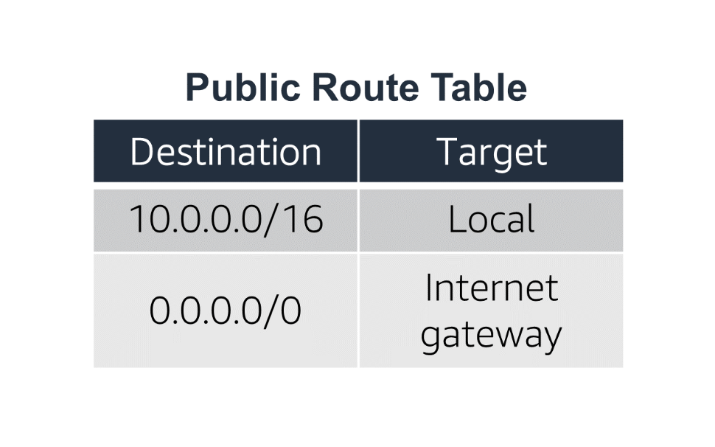

To summarize, you can create a public subnet as follows:

* Create an *internet gateway*
* Create a *route table*
* Add a *route* to the route table that directs *0.0.0.0/0* traffic to the internet gateway
* Associate the route table with a *subnet*, which therefore becomes a *public subnet*

## **Task 5: Launch a Bastion Server in the Public Subnet**

A Bastion Server (also known as a *Jump Box*) is an Amazon EC2 instance in a Public Subnet that is securely configured to provide access to resources in a Private Subnet. Systems Operators can connect to the Bastion Server and then *jump into* resources in the Private Subnet.

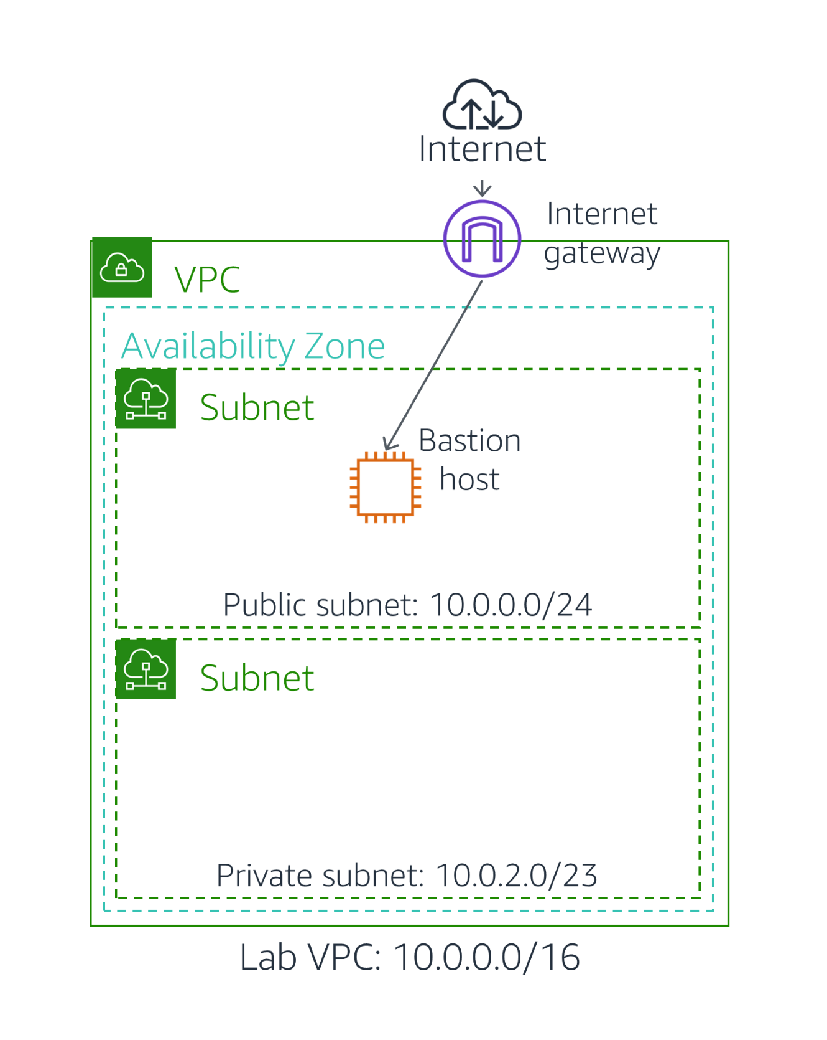

1. On the **Services** menu, click **EC2**.
2. Click **Launch instance** and configure:
   * Step 1 (Choose AMI):
     + **AMI:** Amazon Linux 2
   * Step 2 (Choose Instance Type):
     + **Instance Type:** t3.micro
   * Step 3 (Configure Instance):
     + **Network:** Lab VPC
     + **Subnet:** Public Subnet
   * Step 4 (Add Storage):
     + Use default settings (no changes)
   * Step 5 (Add Tags):
     + Click **Add Tag**
     + **Key:** Name
     + **Value:** Bastion Server
   * Step 6 (Configure Security Group):
     + Use default settings (no changes)
   * Step 7 (Review):
     + **Review and Launch**
     + **View Instances**
3. The Bastion Server will be launched in the Public Subnet. Continue with the next task — there is no need to wait for the instance to be running.

## **Task 6: Create a NAT Gateway**

Resources in a *private subnet* do not have internet connectivity. This is intentional because it protects the resources from being accessed from the internet.

However, sometimes resources in a private subnet need to communicate with the internet to download software updates and access internet services. Thus, you will want to give resources *outbound connectivity* to the internet while keeping them protected from *inbound* access.

This can be accomplished with a **NAT Gateway** that is launched in the public subnet:

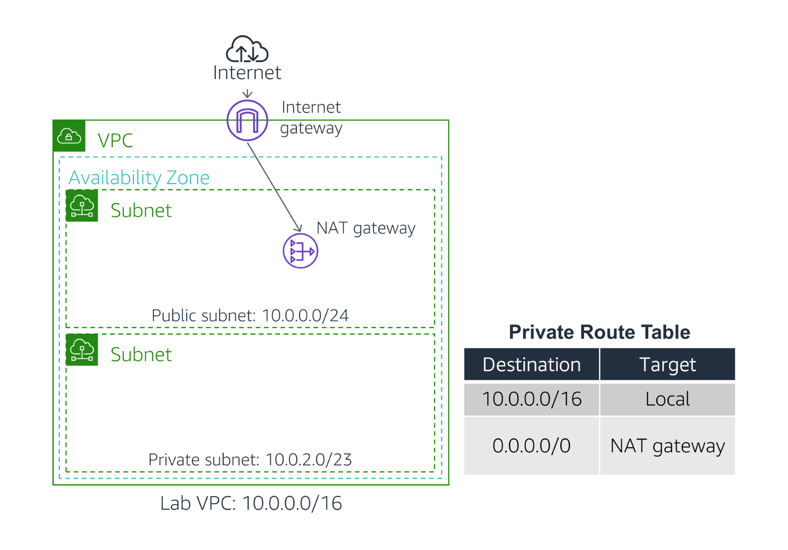

In this task, you will launch a NAT Gateway and configure the Private Route Table to send traffic to the NAT Gateway.

1. On the **Services** menu, click **VPC**.
2. In the left navigation pane, click **NAT Gateways**.
3. Click **Create NAT gateway** then configure:
   * **Subnet:** *Public Subnet*
   * Click **Allocate Elastic IP**
   * Click **Create a NAT Gateway**
   * Click **Edit route tables**
4. You will now configure the Private Subnet to send internet-bound traffic to the NAT Gateway.  
   The Route Tables will already be displayed.
5. In the left navigation pane, click Route Tables. Select **Private Route Table**.
6. Click the **Routes** tab in the lower half of the page.  
   The route table is currently showing only a single entry, which will route traffic locally within the VPC. You will add an additional route to send internet-bound traffic via the NAT Gateway.
7. Click **Edit routes**
8. Click **Add route** then configure:
   * **Destination:** 0.0.0.0/0
   * **Target:** Select *NAT Gateway* then select *nat-* from the list
   * Click **Save routes** then click **Close**
9. Resources in the Private Subnet that wish to communicate with the internet will now have their network traffic directed to the NAT Gateway, which will forward the request to the internet. Responses will flow through the NAT Gateway back to the Private Subnet.  
    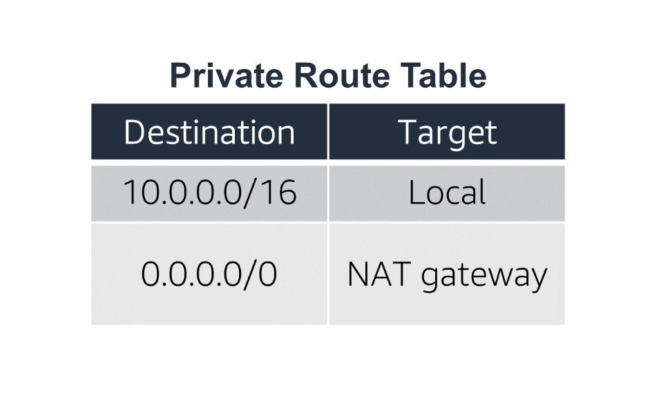

## **Optional Task: Test the Private Subnet**

*This challenge is* ***optional*** *and is provided in case you still have lab time remaining.*

In this challenge, you will launch an Amazon EC2 instance in the Private Subnet and confirm that it can communicate with the internet.



### **Launch an Instance in the Private Subnet**

First, you will launch an Amazon EC2 instance in the Private Subnet.

1. On the **Services** menu, click **EC2**.
2. Click **Launch instance** and configure:
   * Step 1 (Choose AMI):
     + **AMI:** Amazon Linux 2
   * Step 2 (Choose Instance Type):
     + **Instance Type:** t3.micro
   * Step 3 (Configure Instance):
     + **Network:** Lab VPC
     + **Subnet:** Private Subnet (**Not** the Public Subnet!)
     + **User Data** (Under **Advanced Details**): Paste this script:

#!/bin/bash  
# Turn on password authentication for lab challenge  
echo 'lab-password' | passwd ec2-user --stdin  
sed -i 's|[#]*PasswordAuthentication no|PasswordAuthentication yes|g' /etc/ssh/sshd_config  
systemctl restart sshd.service

* + This script will permit login via password. This is simply to make the lab steps easier and is not recommended for normal instance deployments.
  + Step 4 (Add Storage):
    - Use default settings (no changes)
  + Step 5 (Add Tags):
    - Click **Add Tag**
    - **Key:** Name
    - **Value:** Private Instance
  + Step 6 (Configure Security Group):
    - Use default settings (no changes)
  + Step 7 (Review):
    - **Launch**
    - **View Instances**

### **Log into the Bastion Server**

The instance you just launched is in the Private Subnet, so it is not possible to directly log into the instance. Instead, you will first log into the *Bastion Server* in the Public Subnet and then log into the *Private Instance* from the *Bastion Server*.



1. Select the *Bastion Server* and copy the **IPv4 Public IP** (shown in the lower half of the page) to your clipboard.  
   The following instructions now vary slightly depending on whether you are using Windows or Mac/Linux.

### **Windows Users: Using SSH to Connect**

These instructions are for Windows users only.

If you are using macOS or Linux, [skip to the next section](https://labs.vocareum.com/web/1469070/423595.0/ASNLIB/public/docs/lang/en/README.html#ssh-MACLinux).

1. In the **AWS Management Console**, on the **Services** menu, click **EC2**.
2. In the left navigation pane, click **Instances**.
3. Select the **Command Host**.
4. Copy the **IPv4 Public IP** from the Description in the lower pane.
5. Read through the three bullet points in this step before you start to complete the actions, because you will not be able see these instructions when the Details panel is open.
   * Click on the Details drop down menu above these instructions you are currently reading, and then click Show. A Credentials window will open.
   * Click on the **Download PPK** button and save the **labsuser.ppk** file. Typically your browser will save it to the Downloads directory.
   * Then exit the Details panel by clicking on the **X**.
6. Download needed software.
   * You will use **PuTTY** to SSH to Amazon EC2 instances. If you do not have PuTTY installed on your computer, [download it here](https://the.earth.li/~sgtatham/putty/latest/w64/putty.exe).
7. Open **putty.exe**
8. Configure PuTTY to not timeout:
   * Click **Connection**
   * Set **Seconds between keepalives** to 30
9. This allows you to keep the PuTTY session open for a longer period of time.
10. Configure your PuTTY session:
    * Click **Session**
    * **Host Name (or IP address):** Paste the **Public IPv4** value you copied to your clipboard earlier in the lab.
    * Back in PuTTy, in the **Connection** list, expand **SSH**
    * Click **Auth** (don't expand it)
    * Click **Browse**
    * Browse to and select the lab#.ppk file that you downloaded
    * Click **Open** to select it
    * Click **Open**
11. Click **Yes**, to trust the host and connect to it.
12. When prompted **login as**, enter: ec2-user  
    This will connect you to the EC2 instance.
13. [Windows Users: Click here to skip ahead to the next task.](https://labs.vocareum.com/web/1469070/423595.0/ASNLIB/public/docs/lang/en/README.html#ssh-after)

### **Mac and Linux Users**

These instructions are for Mac/Linux users only. If you are a Windows user, [skip ahead to the next task.](https://labs.vocareum.com/web/1469070/423595.0/ASNLIB/public/docs/lang/en/README.html#ssh-after)

1. In the **AWS Management Console**, on the **Services** menu, click **EC2**.
2. In the left navigation pane, click **Instances**.
3. Select the **Command Host**.
4. Copy the **IPv4 Public IP** from the Description in the lower pane.
5. Read through the three bullet points in this step before you start to complete the actions, because you will not be able see these instructions when the Details panel is open.
   * Click on the Details drop down menu above these instructions you are currently reading, and then click Show. A Credentials window will open.
   * Click on the **Download PEM** button and save the **labsuser.pem** file.
   * Then exit the Details panel by clicking on the **X**.
6. Open a terminal window, and change directory cd to the directory where the labsuser.pem file was downloaded.  
   For example, run this command, if it was saved to your Downloads directory:

cd ~/Downloads

1. Change the permissions on the key to be read only, by running this command:

chmod 400 labsuser.pem

1. Return to the terminal window and run this command (replace **<public-ip>** with the **Public IPv4** value you copied to your clipboard earlier in the lab):

ssh -i labsuser.pem ec2-user@<public-ip>

1. Type yes when prompted to allow a first connection to this remote SSH server.  
   Because you are using a key pair for authentication, you will not be prompted for a password.

### **Log into the Private Instance**

You should now be logged into the *Bastion Server*, which is located in the Public Subnet.

You will now connect to the *Private Instance*, which is located in the Private Subnet.

1. In the EC2 console, select **Private Instance** (and deselect any other instances).
2. Copy the **Private IPs** (shown in the lower half of the page) to your clipboard.  
   Note that this IP address is a *private IP address* starting with **10.0.2.x** or **10.0.3.x**. This address is not reachable directly from the internet, which is why you first logged into the *Bastion Server*. You will now log into the *Private Instance*.
3. Run this command into the PuTTY/ssh session, **replacing *PRIVATE-IP* with the IP Address you just copied to your clipboard**:

ssh PRIVATE-IP

1. The command you run should look similar to : *ssh 10.0.2.123*
2. If you are prompted with *"Are you sure"*, enter: yes
3. When prompted for a password, enter: lab-password  
   You should now be connected to the Private Instance. This was accomplished by first connecting to the Bastion Server (in the Public Subnet), then connecting to the Private Instance (in the Private Subnet).

### **Test the NAT Gateway**

The final part of this challenge is to confirm that the *Private Instance* can access the internet.

You will do this by running the **ping** command.

1. Paste this command:

ping -c 3 amazon.com

1. You should see a result similar to:

PING amazon.com (176.32.98.166) 56(84) bytes of data.  
64 bytes from 176.32.98.166 (176.32.98.166): icmp_seq=1 ttl=222 time=79.2 ms  
64 bytes from 176.32.98.166 (176.32.98.166): icmp_seq=2 ttl=222 time=79.2 ms  
64 bytes from 176.32.98.166 (176.32.98.166): icmp_seq=3 ttl=222 time=79.0 ms

1. This indicates that the *Private Instance* successfully communicated with *amazon.com* on the internet.  
   The *Private Instance* is in the Private Subnet, so the only way this was possible was by going via the NAT Gateway. This confirms that your network configuration was successful!

## **Lab Complete**

Congratulations! You have completed the lab.

1. Click End Lab at the top of this page and then click **Yes** to confirm that you want to end the lab.   
    A panel will appear, indicating that "DELETE has been initiated... You may close this message box now."
2. Click the **X** in the top right corner to close the panel.